Experiment 1: Print system information such as OS name, Python version, and current working directory using Python.
Code:
import os
import sys
import platform

print("OS Name:", platform.system())
print("OS Version:", platform.version())
print("Python Version:", sys.version)
print("Current Working Directory:", os.getcwd())
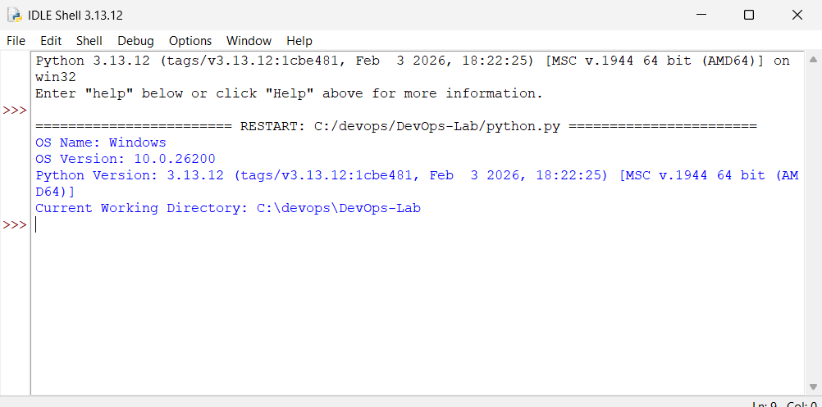
Experiment 2: Create directories and files using Python and write user input data into files.
Code:
import os

dirname = "TestFolder"
os.makedirs(dirname, exist_ok=True)

filename = os.path.join(dirname, "data.txt")

data = input("Enter text to write into file: ")

with open(filename, "w") as f:
f.write(data)

print("File created and data written successfully.")
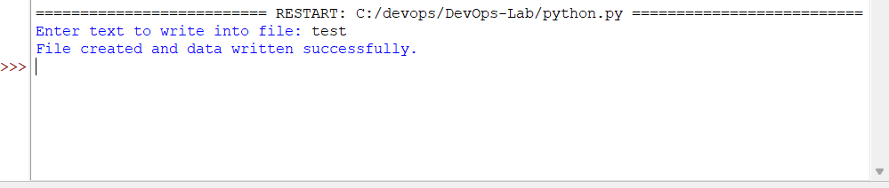
Experiment 3: Read a text file and count the number of lines, words, and characters.
Code:
filename = "data.txt"

with open(filename, "r") as f:
content = f.read()

lines = content.split("\n")
words = content.split()

print("Lines:", len(lines))
print("Words:", len(words))
print("Characters:", len(content))
Experiment 4: List all files and subdirectories from a given path.

Experiment 5: Check whether a file exists and display its size and last modified time. Experiment 6: Monitor CPU and memory usage using Python. Experiment 7: Delete files older than N days automatically. Experiment 8: Rename multiple files in a directory using Python scripting. Experiment 9: Compress and extract directories using Python. Experiment 10: Simulate task scheduling using Python. Experiment 11: Automate Git repository initialization and perform commit operations using Python. Experiment 12: Track file changes and log modification details into a log file. Experiment 13: Automate pushing source code to a remote GitHub repository. Experiment 14: Implement Git branching and merging using Python scripts. Experiment 15: Analyze Git commit history and generate reports. Experiment 16: Automate Git pull, status check, and commit verification. Experiment 17: Simulate multiple contributors and resolve merge conflicts.

